DAX Query Requirements :
- Display the 10 artists with the lowest number of social media followers.
OUTPUT:
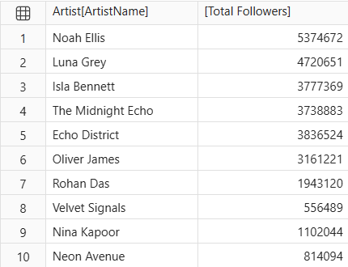

- Display the 5 oldest albums based on their release dates.
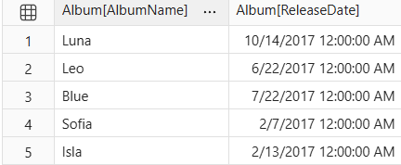
- Display the total number of streaming records, average listening minutes, maximum rating and minimum rating in a single row.
- Display the total revenue and average rating for each PlaylistSource.
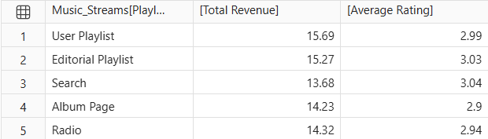

- Display the 5 tracks with the highest total StreamCount, along with their total streams.
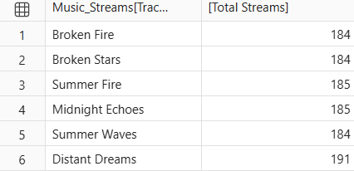

- Display each PrimaryGenre and the number of unique artists belonging to that genre.
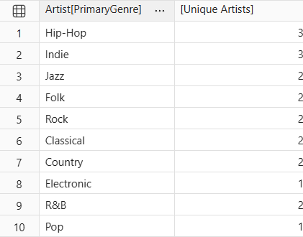

- Display the total revenue generated from listeners in each ListenerCountry.
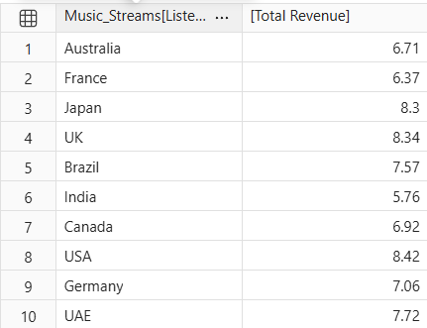

- Display the 5 countries with the highest number of unique listeners.
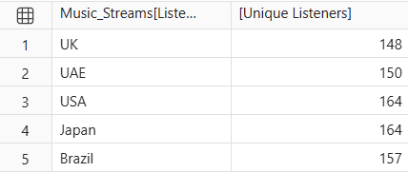
- Display each PlaylistSource and its average SkipCount.
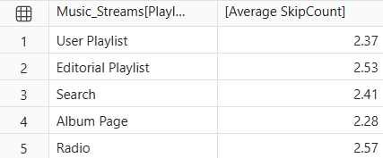
- Display the 5 albums with the highest ProductionCostUSD.
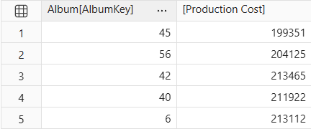
- Display the total revenue generated in each year using the Date table.
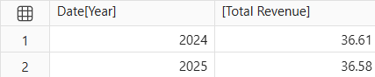
- Display total skips for every combination of Device and PlaylistSource.

Music_Streams[Device] | Music_Streams[PlaylistSource] | [Total Skips]
Smart Speaker | User Playlist | 210
Smart TV | User Playlist | 134
Desktop | User Playlist | 174
Mobile | User Playlist | 193
Tablet | User Playlist | 165
Smart Speaker | Editorial Playlist | 180
Smart TV | Editorial Playlist | 206
Desktop | Editorial Playlist | 174
Mobile | Editorial Playlist | 156
Tablet | Editorial Playlist | 211
Smart Speaker | Search | 153
Smart TV | Search | 147
Desktop | Search | 156
Mobile | Search | 180
Tablet | Search | 176
Smart Speaker | Album Page | 155
Smart TV | Album Page | 168
Desktop | Album Page | 158
Mobile | Album Page | 135
Tablet | Album Page | 197
Smart Speaker | Radio | 184
Smart TV | Radio | 174
Desktop | Radio | 194
Mobile | Radio | 159
Tablet | Radio | 237
13.Display each ArtistType and its average number of social followers.
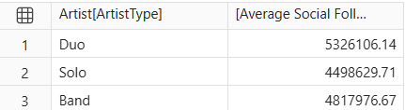
- Display each ListenerCountry, its total revenue, number of streaming records and average revenue per record.

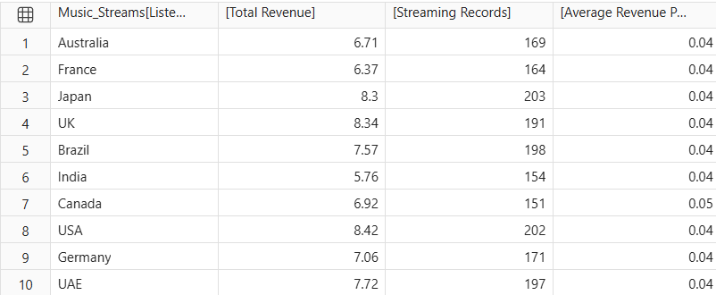

15. Display the number of unique listeners and average listening minutes for every combination of SubscriptionType and Device.
Music_Streams[SubscriptionType] | Music_Streams[Device] | [Unique Listeners] | [Average Listening Minutes]
Free | Smart Speaker | 135 | 30.703086419753085
Family | Smart Speaker | 53 | 29.987272727272728
Premium | Smart Speaker | 87 | 31.84040404040404
Student | Smart Speaker | 33 | 29.285714285714285
Free | Smart TV | 145 | 29.58809523809524
Family | Smart TV | 45 | 29.870833333333334
Premium | Smart TV | 76 | 28.873863636363637
Student | Smart TV | 32 | 34.002941176470586
Free | Desktop | 150 | 32.74519774011299
Family | Desktop | 46 | 29.43541666666667
Premium | Desktop | 102 | 31.087272727272726
Student | Desktop | 36 | 28.7
Free | Mobile | 138 | 31.525827814569535
Family | Mobile | 51 | 28.5188679245283
Premium | Mobile | 98 | 32.51467889908257
Student | Mobile | 32 | 31.675757575757576
Free | Tablet | 171 | 30.24522613065327
Family | Tablet | 52 | 31.503773584905662
Premium | Tablet | 92 | 31.761165048543692
Student | Tablet | 37 | 26.267567567567568

